**DEPLOYMENT**

Deployment is the most common and recommended way to manage pods in Kubernetes. It is built on top of ReplicaSet and provides additional features, including rolling updates, rollbacks, and versioning.

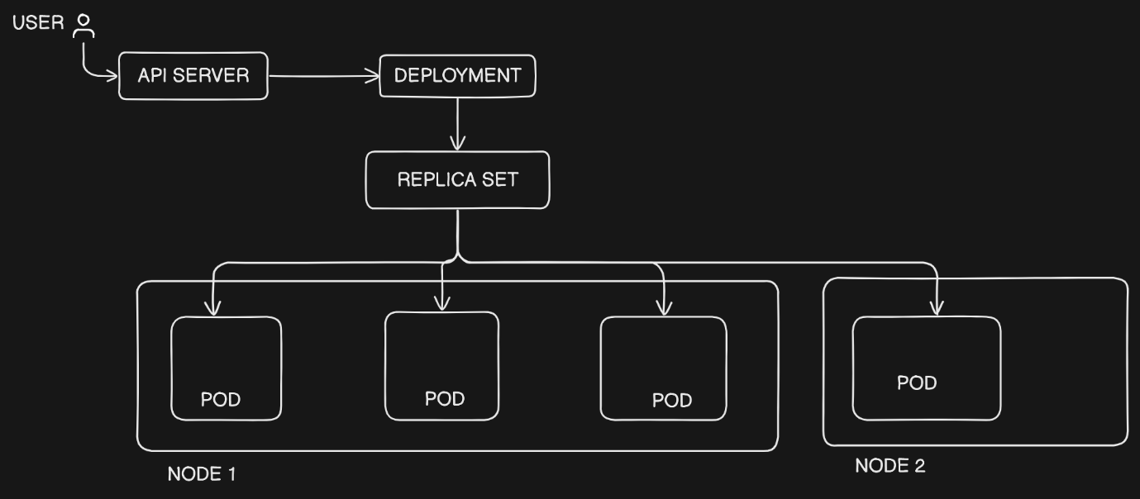

Let’s say you want to change the API version from 1.1 🡪 1.2, if every POD goes to update, we will face huge downtime to avoid the downtime we will use deployment.

We have 3 POD’s running and you need to change the version, one POD will go to update and other two will manage the traffic. If traffic increases it can also spin up new POD to manage the traffic.

Once the update is done traffic will flow to that POD and next POD will go for an updated.

We can rollback to previous version also.

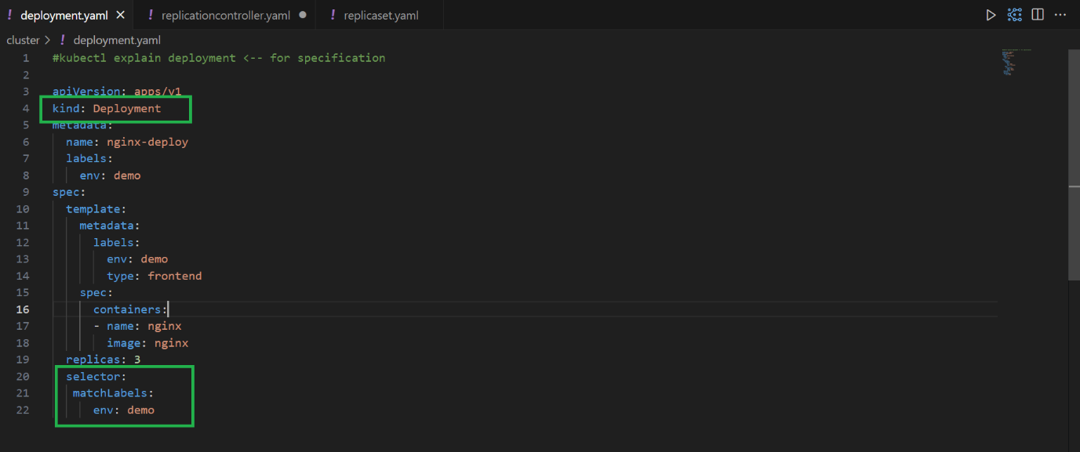

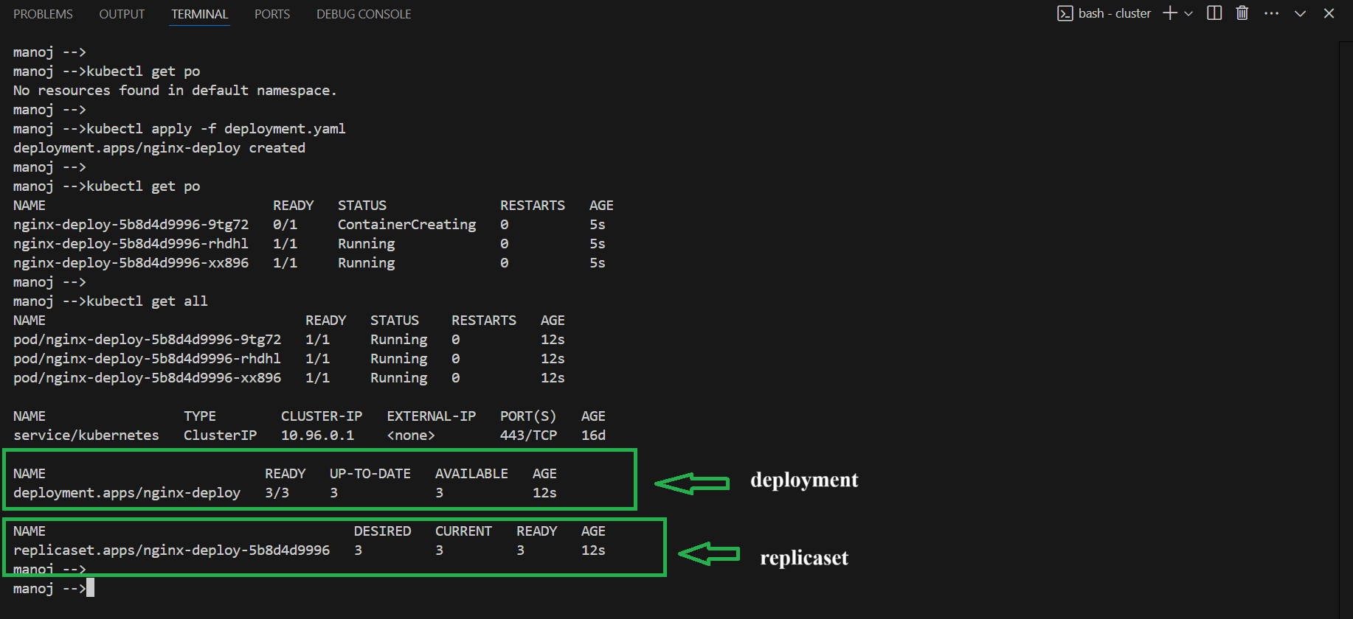

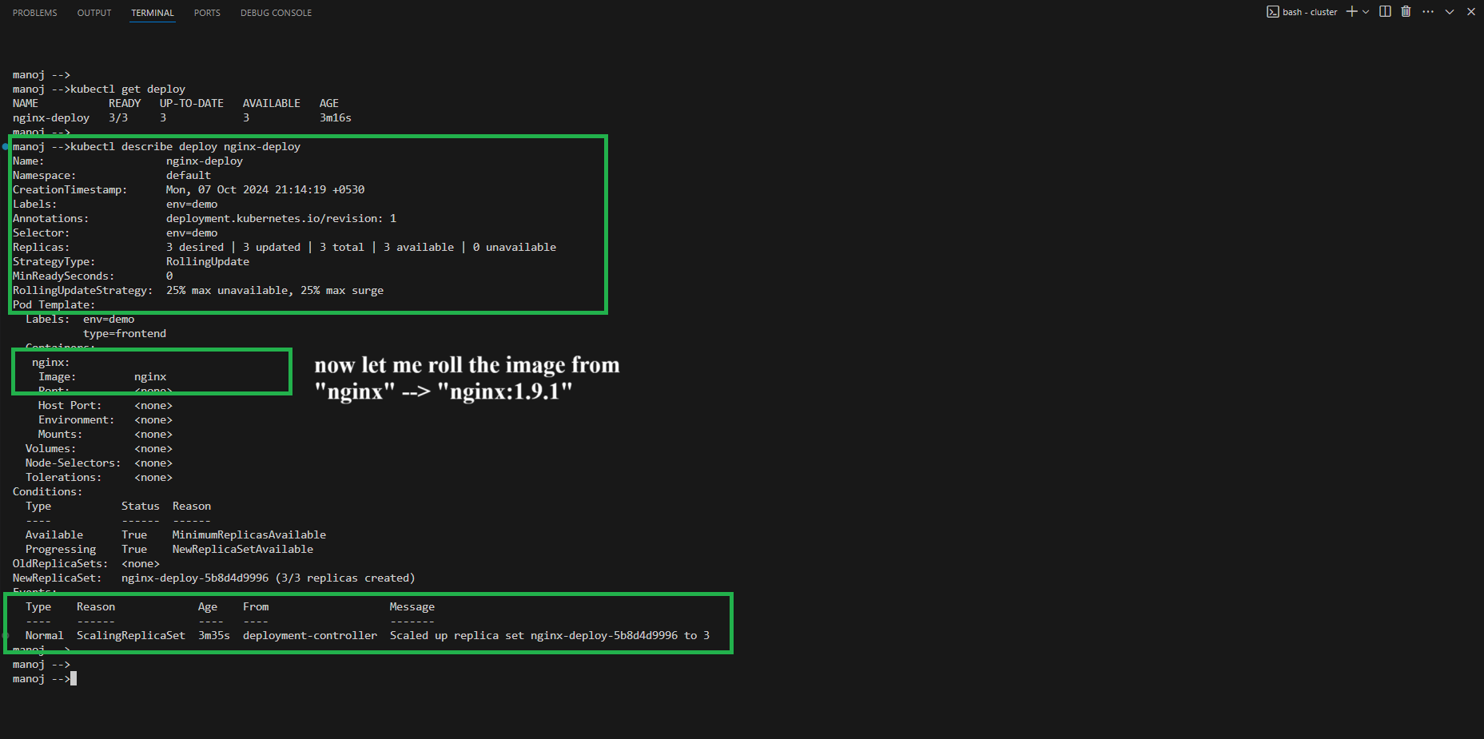

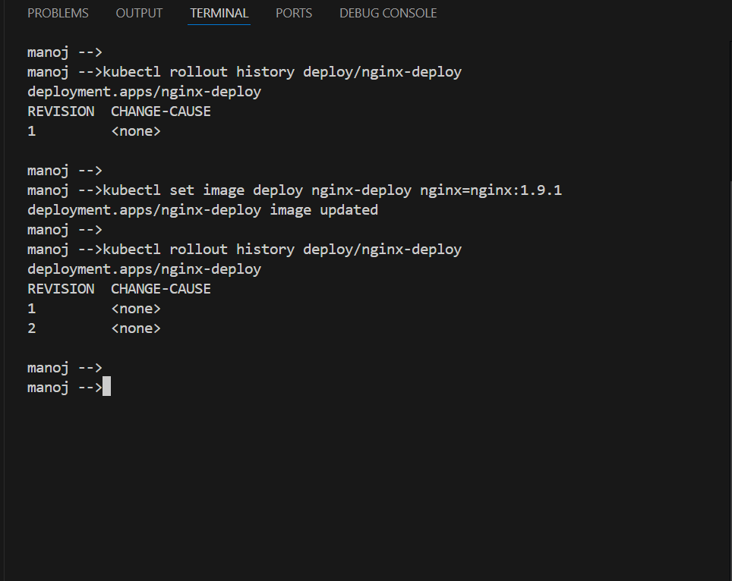

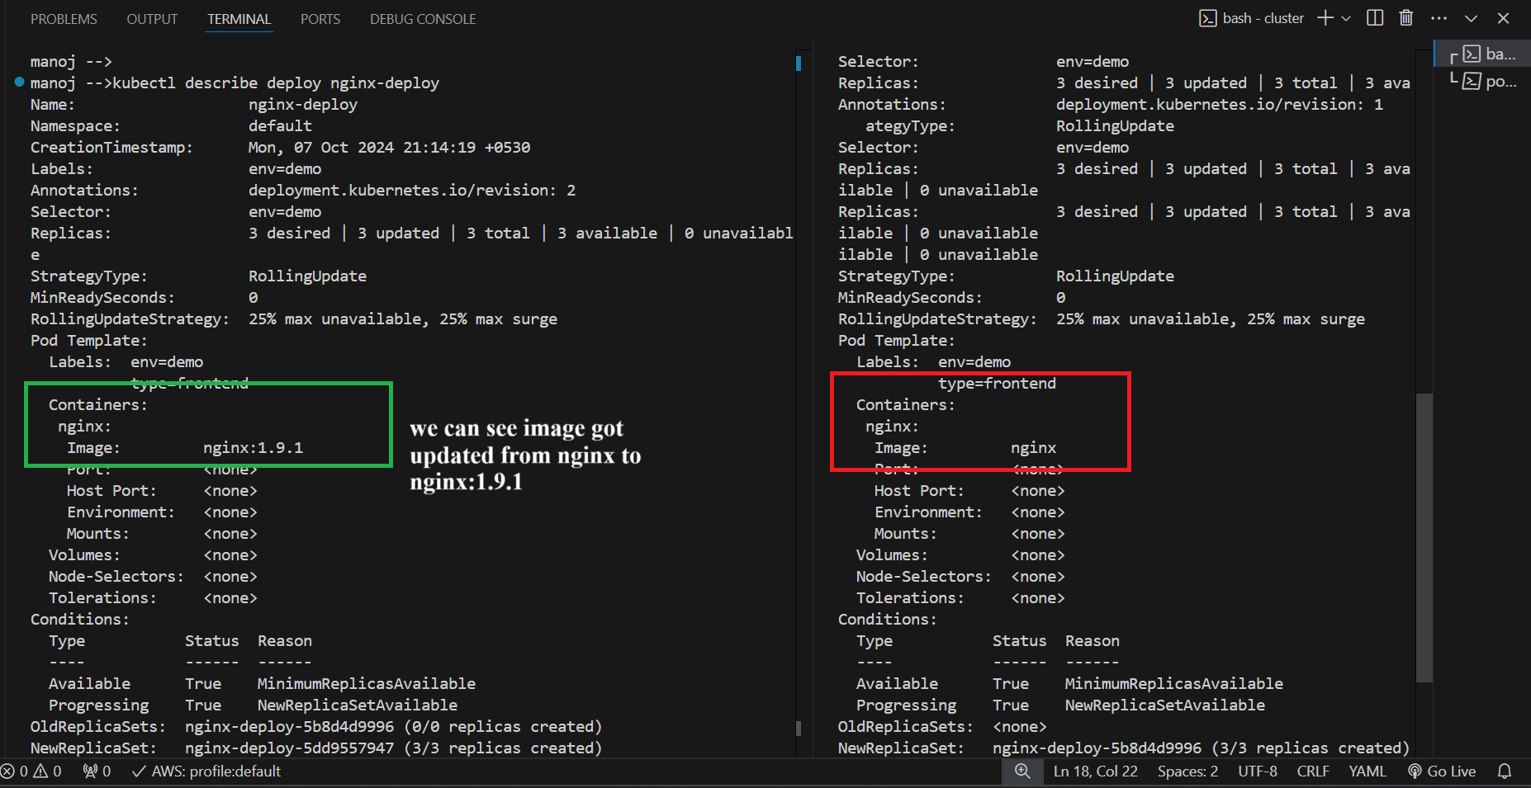

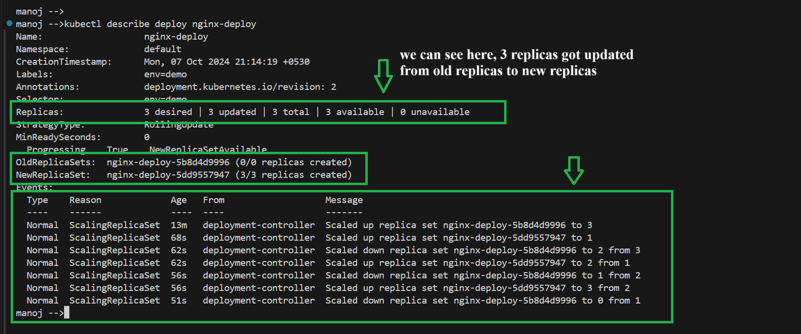

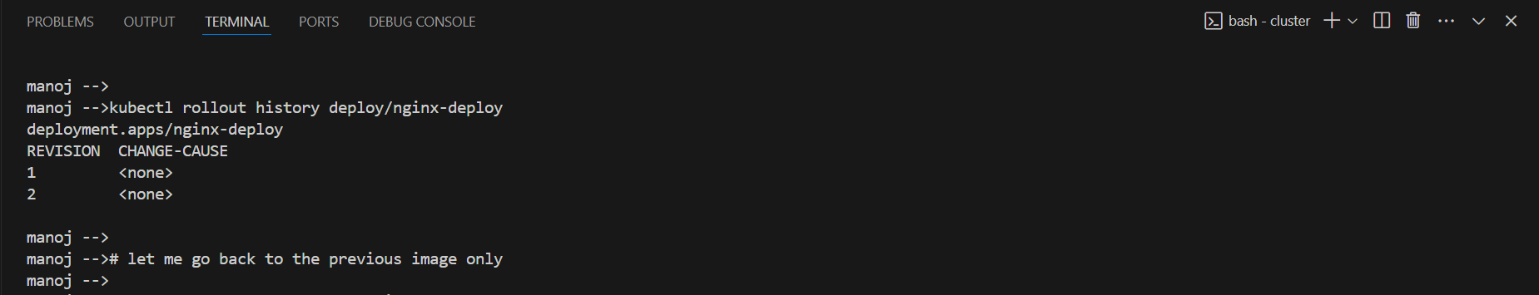

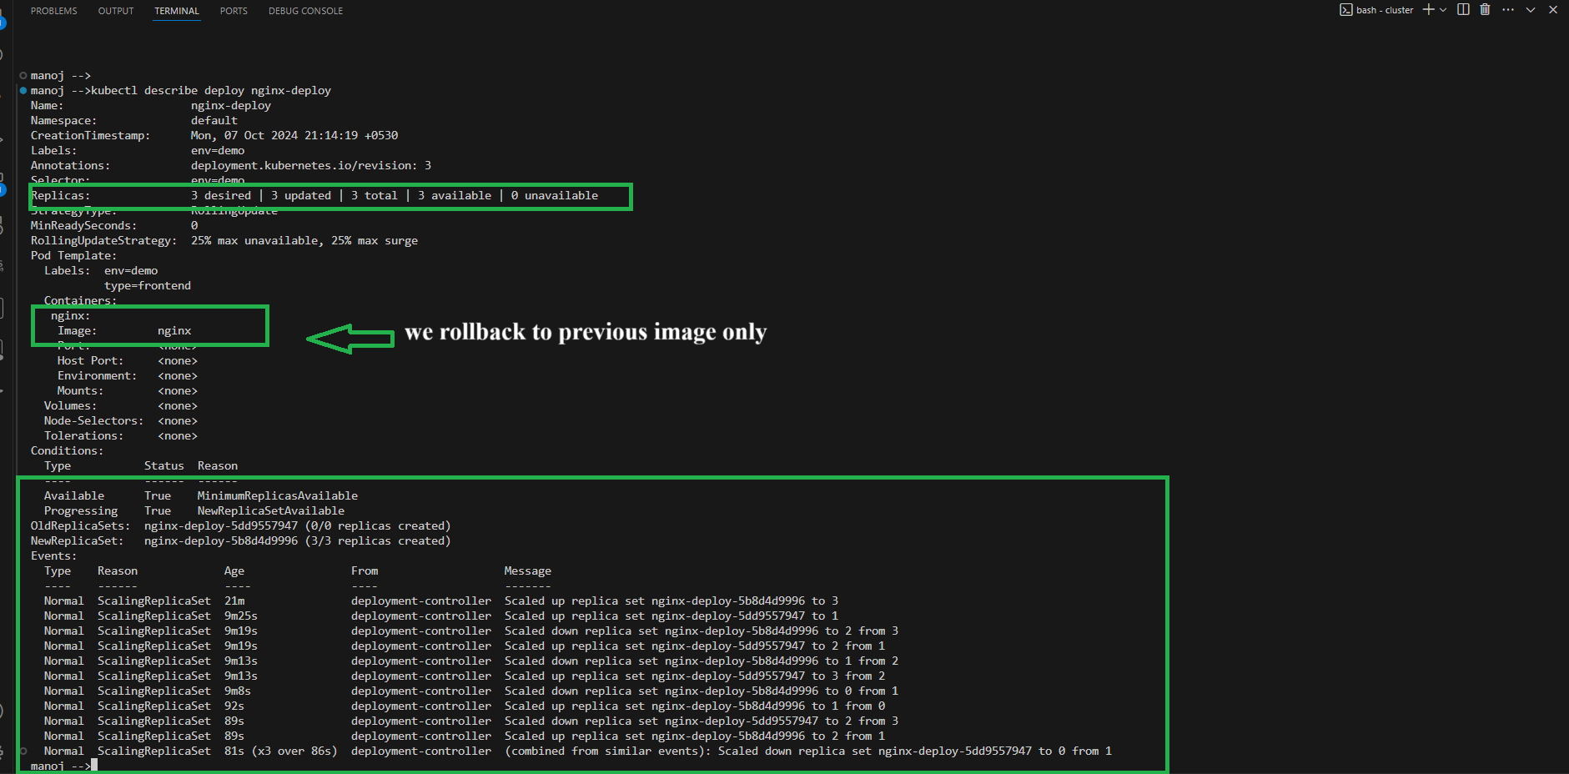

Key points:

* Automates the creation and management of ReplicaSets and their pods.
* Supports rolling updates to ensure zero downtime during updates.
* Supports rollbacks to previous versions in case of failures.
* Can pause and resume deployments.

**Key Differences**

* **Replication Controller** is older and lacks features like rolling updates.
* **ReplicaSet** is an improvement on Replication Controller but is usually managed by Deployments.
* **Deployment** is the most advanced and recommended method, providing features like rolling updates, rollbacks, and better pod management.